

**JOMO KENYATTA UNIVERSITY OF AGRICULTURE AND TECHNOLOGY**

**DEPARTMENT OF ELECTRICAL AND ELECTRONIC**

**ENGINEERING**

**BSc Electrical and Electronic Engineering**

**Final Year Project Report**

**Title: M-PESA INTEGRATED AUTOMATED COFFEE VENDING MACHINE**

**MAVYUVA, KELVIN KASEE**

**ENE211– 0023/2018**

*Final Year Project Report submitted to the Department of Electrical and Electronic*

*Engineering, Jomo Kenyatta University of Agriculture and Technology, in partial fulfilment of the requirements for the award of a Bachelor of Science* *degree in Electrical and Electronic Engineering*

**2023**

# **DECLARATION**

This project report is my original work, except where due acknowledgement is made in the text, and to the best of my knowledge has not been previously submitted to Jomo Kenyatta University of Agriculture and Technology or any other institution for the Award of a degree or diploma.

SINATURE: ………………………………DATE: ……………………………

NAME: MAVYUVA, KELVIN KASEE

REG NO: ENE211– 0023/2018

TITLE OF PROJECT: M-PESA INTEGRATED AUTOMATED COFFEE VENDING MACHINE

**SUPERVISOR CONFIRMATION:**

This project report has been submitted to the Department of Electrical and Electronic Engineering, Jomo Kenyatta University of Agriculture and Technology, with my approval as the University supervisor:

SINATURE: …………………………………DATE: …………………………………

NAME: Mr. Muhia

# **DEDICATION**

I dedicate this final year project, on M-PESA integrated automated coffee vending machine, to all the coffee lovers around the world. Your love and passion for coffee has inspired me to create a machine that not only enhances your coffee experience but also makes your life easier. This project is a tribute to all the hardworking individuals who rely on coffee to fuel their days and nights. May this machine bring more convenience and joy to your daily routine.

# **ACKNOWLEDGEMENT**

I would like to express my sincere gratitude to all those who have contributed to the successful completion of this final year project on M-PESA integrated automated coffee vending machine.

First and foremost, I would like to thank my supervisor, Mr. Muhia, for his guidance, support, and valuable insights throughout the entire project. His constant encouragement, patience, and expertise have been a driving force behind the completion of this project.

I would also like to thank the faculty and staff of the School of Electrical and Electronics Engineering, for providing me with the necessary resources and facilities to carry out this project. Their commitment to education and research has greatly contributed to the development of my skills and knowledge.

Last but not least, I would like to thank my family and friends for their unconditional love, support, and motivation throughout my academic journey. Their constant encouragement and belief in me have been a source of strength and inspiration.

Thank you all for being a part of this project and for helping me bring my ideas to life. Your support has been instrumental in the success of this project.

**Table of Contents**

**DECLARATION i**

**DEDICATION ii**

**ACKNOWLEDGEMENT iii**

**LIST OF FIGURES vi**

**LIST OF TABLES vii**

**ABSTRACT ix**

**CHAPTER ONE 1**

**1.0. INTRODUCTION 1**

**1.1. BACKGROUND INFORMATION 1**

**1.2. PROBLEM STATEMENT 3**

**1.3. JUSTIFICATION 3**

**1.4. OBJECTIVES 4**

**1.4.1. MAIN OBJECTIVE 4**

**1.4.2. SPECIFIC OBJECTIVES. 4**

**1.5. PROJECT SCOPE 4**

**CHAPTER TWO 5**

**2.0. LITERATURE REVIEW 5**

**2.1. CURRENT TRENDS 5**

**2.2. TECHNOLOGIES USED 7**

**2.2.1. NON IOT BASED VENDING MACHINE TECHNOLOGIES 8**

**2.2.2. EXISTING IOT BASED VENDING MACHINE TECHNOLOGIES 8**

**CHAPTER THREE 10**

**3.0. METHODOLOGY 10**

**3.1. BLOCK DIAGRAM REPRESENTATION OF THE PROPOSED SYSTEM 10**

**3.2. SYSTEM IMPLEMENTATION 11**

**3.2.1. INPUT INTERFACE 11**

**3.2.2. DISPLAY INTERFACE 11**

**3.2.3. POWER SUPPLY 11**

**3.2.4. MICROCONTROLLER 11**

**3.2.5. SOFTWARE 12**

**3.2.6. DELIVERY SYSTEM 12**

**3.3. FLOWCHART OF THE SYSTEM OPERATION 12**

**CHAPTER FOUR 15**

**4.0. RESULTS AND DISCUSSION 15**

**4.1. SYSTEM PROTOTYPE 15**

**4. 2. USER INTERFACE 16**

**4.3. CONTROL MODULE 17**

**4.4. PAYMENT SYSTEM 17**

**4.5. TESTING 18**

**4.5.1. MPESA STK REQUESTS 20**

**4.5.2. QUANTITY DISPENSED 22**

**4.5.3. DATABASE ENTRIES 23**

**4.5.4. OVERRIDE SYSTEM 24**

**4.6. DISCUSSION 26**

**CHAPTER FIVE 28**

**5.0. CONCLUSION AND RECOMMENDATION 28**

**5.1. CONCLUSION 28**

**5.2. RECOMMENDATIONS 29**

**REFERENCES 32**

# **LIST OF FIGURES**

Figure 3.1. Block diagram of the system 9

Figure 3.2. Flowchart of the system 12

Figure 4.1. System prototype 15

Figure 4.2. User interface 16

Figure 4.3. Control module 17

Figure 4.5. Normal operation of the automated coffee machine 19

Figure 4.5.1. M-pesa push notification 20

Figure 4.5.2. A sample of successful transaction recorded in database 21

Figure 4.5.3. A sample of unsuccessful transaction recorded in database 21

Figure 4.5.4. Comparison of small, medium and large quantities of dispensed coffee 22

Figure 4.5.5. Comparison of two large quantities of dispensed coffee 23

Figure 4.5.6. M-pesa payment confirmation message received by client 23

Figure 4.5.7. Database record of the M-pesa transaction. 24

Figure 4.5.8. Password-protected override system 24

Figure 4.5.9. Error message on the override system 25

Figure 4.6. Percentage of micro and small enterprises (MSEs) using mobile money for business transactions in Kenya from 2018 to 2021 26

# **LIST OF TABLES**

Table 1: Project time plan 15

Table 2: Project budget 16

**ABBREVIATIONS**

ATM Automated Teller Machine

CPS Cyber Physical System

DB Database

GPS Global Positioning System

HD High Definition

HTTP Hypertext Transfer Protocol

ID Identification

IoT Internet of Things

IR Infrared

LCD Liquid Crystal Display

LED Light-emitting Diode

OLED Organic Light-emitting Diode

PHP Hypertext Preprocessor

PLC Programmable Logic Controller

RFID Radio Frequency Identification

RVM Reverse Vending Machine

SQL Structured Query Language

STK SIM Toolkit

TVM Ticket Vending Machine

# **ABSTRACT**

Automated machines known as vending machines allow the general public to get a range of products after a transaction. Vending machines are preferred because they are simple to operate, have minimal operating expenses, and provide quicker service. They also require little to no human labour. In light of this, an automated coffee vending machine integrated with a reliable payment system was developed in this project. The automated coffee machine was developed to reduce the costs of operations associated with the existing manual coffee service shops and to alleviate the need of manually authenticating transactions. The coffee machine was designed to have a control module that precisely processes user inputs, initiates and confirms user payments and dispenses the desired amount of coffee. The payment system integrated on the machine is based on the M-PESA STK method and it facilitates reliable payments and enhances the security of the vending transactions. Upon completion, the automated coffee machine was accurately performing its intended functions and could allow user to buy coffee using the M-PESA payment method. An override system was also achieved in this project to allow for manual processes in cases where clients would wish to pay with cash. Generally, the project was a success and future improvements can also be made to increase its scope and efficiency of operations.

***Keywords:*** *Vending machines, Automated coffee vending machine, cashless payments, and control system.*

# **CHAPTER ONE**

## **INTRODUCTION**

This chapter will provide a background study of vending machines and explain the achievements and limitations of these machines across the world. It will also discuss about the project's main objective and its specific objectives, and the benefits that of the project.

## **1.1. BACKGROUND INFORMATION**

The demand for automated vending machines has been on the rise due to their efficiency and ease of operation. Automated machines operate with minimal or no human intervention, making it cheaper for vendors across the world. According to Gruber et al., 2016 [1] a vending machine is a coin-operated device used to offer particular goods & beverages. Technology advancements are leading to the development of machines that use plastic money instead of coins and the emergence of “machines that provide service at an unattended point of sale with monetarily driven equipment". It can also be described as an electronic device that distributes a product to a customer after receiving a specific sum of money. Vending machines typically offer processed foods and drinks rich in salt, sugar, and/or fat. Depending on what one needs, getting an order served at a restaurant can take up to 30 minutes [2]. Other consumers will be disappointed by these lines, and the business will lose money. To improve this system, the introduction of vending machines can be advantageous. They are easily installed and maintained, and can occupy locations such as hospitals, universities and schools. The automated vending machines are designed in a way that customers can easily input their orders and receive their ordered items at the output. Various electronics, electrical and mechanical engineering principles are employed in fabricating these automated machines [3].

An observable trend in supermarkets and other service shops is the existence of queues or crowds which in the end causes buyers to spend more time in getting their services. In addition, some customers may feel disappointed, and the vendor may lose some income due to the delays. Most service shops also incur the cost of hiring workers to oversee the purchase of items and authenticate customer transactions. Cash payments are also a popular payment method in most shops, which poses a risk to the security of payments. As a result, automated machines are required to avoid all these problems while providing various benefits to customers and vendors.

Automated vending machines is a type of machine that has gained a lot of attraction in the recent years [4]. The vending machine employs a technology that can dispense the products to the customers without the need of staff or any human assistance. The increased admiralty for vending machines has also been contributed by their ability to serve the wide clientele with a variety of products ranging from green grocery to processed products such as snacks and beverages. Other benefits associated with the automated vending machines include reduced labour cost, flexibility in time and their contribution in reducing the time spent by customers. Vending machines have the mobility and vendors can easily move them to new locations where optimal profits can be gained. They can also be operational for 24 hours throughout the year, and customers can purchase products at any time of the day. These vending machines are available worldwide, and Kenya has also made significant strides in adopting the technology.

The COVID-19 crisis caused an increase in the usage of vending machines internationally. The income from vending machines across the world is also estimated to reach US$146.6 Billion in 2027 [5]. This prediction offers a great sense of hope and motivation to current and aspiring vendors in the use of automated vending machines. Customer behaviour has changed over the recent years, and most customers now want unmanned retail models where human contact is minimal or non-existent. People are also shifting to cashless payments and the vending machines meet all these customer behaviours and preferences. Similarly, to any other technology, vending machines have their own limitation that could pose losses to both the investors and customers. Vending machines face the risk of destruction or faulty programming which could lead to improper functioning such as continuous dispensing of a product. Unruly groups or jealous competitors also threaten vending machines used in public places [6]. Therefore, investors need to consider these limitations and devise ways to eliminate outside threats to vending machines.

The demand for innovation, high resolution, touch-enabled screens, non-cash payment options, Internet of Things, and cloud-based services is not an exception for vending machines. Most vending machines are built with a Vending Machine Controller that controls fundamental subsystems, including payments, temperature management, lighting, and product handling. The typical microcontroller used for the vending machine controller lacks the processing power, connection, manageability, and ease of reprogramming required to handle new post-installation services. Programmable logic controllers, such as the Siemens PLC, Mitsubishi PLC FX2N-32MR, and processor-based controllers used to implement the control systems in vending machines, have advanced technologically from basic low-end microcontrollers [7]. The control system offers sophisticated system technologies, such as HD touch screens and software for remote management devices, that go far beyond the provision of food and drink to include services like advertising platforms. Manual vending machines require human skills and input, hence, in places like malls, airports queues are created. All forms of payment, including coins, bank cards, and mobile devices, are accepted by high– tech vending machines. The ability to purchase multiple items simultaneously makes the automated vending machines effective, quick, and dependable.

In Kenya, vending machines are slowly gaining popularity among local retailers. Some shopkeepers have switched from selling packaged milk to having vending machines that dispense fresh milk. The business has been termed to be lucrative, with the shopkeepers registering higher profits due to the increased number of customers attracted by the cheaper milk as compared to packaged milk [8]. Numerous other vending machines have also popped up across Nairobi and its surrounding cities for selling cooking oil, clean renewable cooking oil and sanitary pads. The presence of these vending machines in the country have created room for growth of the technology and the introduction of new vending machines that fill the existing gaps in service delivery while increasing the efficiency of such systems. An automated coffee vending machine which allows customers to buy coffee using mobile money payments was developed in this project.

## **PROBLEM STATEMENT**

The current solutions to assist coffee shops with their purchase transactions and authenticate customer payments are expensive, inefficient, and may cause dissatisfaction to customers. In light of this, this project involves the research and development of an automated coffee vending machine with a reliable payment system, integrated with the M-PESA STK method, in order to reduce the cost of labour, improve the efficiency of the purchase transactions, and to enable customers to securely make payments.

## **JUSTIFICATION**

The development of an automated coffee vending machine is necessary in order to meet the growing demand for easily accessible coffee. This project is justified as it seeks to provide a convenient and secure payment system that supports the M-PESA STK method, ensuring the safety and reliability of consumer transactions. Additionally, automating the vending process can help reduce the costs of operations for businesses, while the secure payment system will raise the overall trustworthiness of the transaction. This project will take an important step towards modernizing the coffee vending process, potentially leading to greater customer satisfaction and improved commercial efficiency.

## **OBJECTIVES**

### **MAIN OBJECTIVE**

To develop an automated coffee vending machine with a reliable payment system based on M-PESA STK method.

### **SPECIFIC OBJECTIVES.**

1. To develop an automated coffee vending machine.
2. To develop a control module that accurately dispenses the desired quantity of coffee.
3. To integrate an M-PESA STK-based payment system with the vending system.
4. To test the reliability of the automated coffee vending machine.

## **PROJECT SCOPE**

This project covers development an automated coffee vending machine that can securely and accurately dispense one type of coffee. This machine is specifically designed for the Kenyan market due to its M-PESA payments feature and it can remain operational for 24 hours a day. The payment system supports M-PESA STK as the primary payment method for the vending machine.

# **CHAPTER TWO**

## **2.0. LITERATURE REVIEW**

This chapter will focus on the relevant existing research related to the project, such as automated vending machines and payment systems. It will provide an analysis of the current systems implemented, and use this to compare with the project's goals. This chapter will also present the theoretical knowledge of the control systems, payment systems and technologies used in the project.

## **2.1. CURRENT TRENDS**

The main aim of this literature survey is to critically analyse the different methodologies, case studies, software and hardware implementations that have been conducted before and are related to this project. According to Preetilatha et al., 2014 [4] vending machines have been widely implemented as significant distribution channels in public and private sectors. Vending machines have been applied to automate pill dispensation in different areas, such as the medical field. Retailing businesses have also adopted vending machines in the sale of snacks, stationery, beverages and water. A research done by Mohan et al. 2017 [9] presented the description of a Coin-Operated Water Dispenser that dispenses water on the detection of the right coin. The researchers argued that the water dispenser would help to provide water to people at a low cost and it could be installed on roads, railways stations and other public places.

However, other researchers have disputed the security of cash-based methods in vending machines. According to Ramzan et al., 2017 [10] coin based vending machines can be easily hacked by pulling the coin back after successful vending by trying it with a thread. The researchers also argued that cash-based vending machines are faced with other challenges such as the inability of coin sensors to process multiple sizes of coin types, and the issue of the coin storage becoming full. Consumers also don’t have cash all the times. Alternatively, the researchers suggested the implementation and employment of a cashless and secure system in vending machines by using RFID technology to replace the existing cash-based system. The use of RFID technology in vending machines has also been suggested in other studies, whereby the consumers are issued with RFID cards charged with money and from which deductions are made after successful product delivery [11].

In medicine, automatic medicine vending machines help patients who have difficulty following their prescriptions and those who cannot identify their medicines. The automatic vending machines are designed to dynamically receive input for the user and then dispense the required type of medicine [12]. The user input follows a doctor’s prescription and the vending machine is capable of handling various prescriptions. The machine also includes a money transfer system that facilitates payment for the medicine via a debit or credit card. As described, this system only works for patients who have already visited a physician and gotten a prescription for their condition. Kumar et al., 2020 [13] suggested an alternative Solar Powered Medic Vending machine that would be applicable in schools, stations and other areas where there is no pharmacy nearby. The product would be used to dispense first-aid items and other necessary medicines for people needing immediate attention. Other benefits of this machine include the use of renewable power source and a magnetic card reader to unlock the product for the user.

Recycling has emerged as a cutting-edge strategy for efficient waste management given the rising volume of waste produced by humans and the limited availability of landfill sites for disposal [14]. People may grow less likely to recycle as a result of the current practice of bringing rubbish to recycling facilities in large quantities. Based on the idea of a reverse vending machine (RVM), an automated recycling bin with a reward system has been devised and implemented in various nations, including Greece, Japan, Europe, South Korea, America, and China, to address this issue. These devices are becoming more and more popular as they free up labour, save time and energy, inspire workers, and are economical. Such a device's usage is as easy as using an ATM machine. This machine comes with a bottle-accepting inlet. The bottle could be put inside by the user. Image processing is utilized to determine whether or not to accept the bottle for recycling after it has been inserted into the input. The depositor can receive the reward points if the bottle is accepted by inputting their special PIN. If rejected, the bottle is returned to the user [15]. Hence, Reverse Vending Machine is meant to encourage recycling habit by giving rewards to depositors for every recycled item in terms of reward points.

Since their inception, self-service ticket vending machines (TVMs) have gradually replaced the conventional ticket counter by becoming an essential distribution channel in the public transportation industry [16]. TVMs are advantageous due to their 24/7 accessibility, simplicity of use, quick ticket purchasing speed, and flexibility of payment options. They are also known to shorten lines and enhance customer service. They also provide a number of accessibility challenges, though. For instance, the small tactile characters may make it difficult for blind persons to use them, and older users may have trouble reading the small print on the screen, especially in dim lighting. Studies have shown that users with impairments are much less satisfied with TVMs than users without disabilities [17]. The studies have also found that TVMs would continue to be inaccessible and frustrate persons with impairments if accessibility requirements of users with disabilities are not taken into account.

Vending machines have also been applied in other areas in dispensing snacks, stationery and other products. A case study by Desai et al. 2017 [18] proposed the design of an Automatic Chocolate Vending Machine by using Arduino Uno. The Arduino based vending machine would make sales for different types of chocolate. The study suggested using a cashless payment system based on RFID technology to overcome the challenges of a coin-based vending machine. Another study by Preetilatha et al. 2014 [4] proposed a microcontroller based stationery vending machine that dispatches A4 sheets, pencils and other stationeries using RFID technology to process the payments. The system would scan the RFID card and allow users to select their required item which would be dispatched at the output after successful payment. Based on these studies, it is evident that vending machines are becoming more popular in the public and private sectors and different technologies have already been adopted in the design and implementation of these machines.

## **2.2. TECHNOLOGIES USED**

The vending sector benefits from the technology advancements that are speeding innovation and changing markets due to the internet. The availability of vending machines that may provide services like mobile phone charging, free Wi-Fi, and printing from USB drive platforms is currently driving demand from users [7]. Some vending machines include Wi-Fi and GPRS so that inventory level information may be gathered and communicated to a central database to help create a restocking strategy. All of these systems are driven by the machine control system. The control system mainly consists of the relay control, microcomputer control and PLC control [19]. There are various types of machine payment systems. The coin payment mechanism is the most widely used. The machine includes a combined mechanical and electronic technology that results in a quick product delivery process [20].

As technology continues to advance at a breakneck pace, firms worldwide attempt to increase consumer engagement through new inventive business models and marketing strategies. Cyber Physical Systems (CPS) and the internet allow cooperating computational elements to access and use data-accessing and data-processing services that are offered on the internet to facilitate system performance [21]. Today's payment systems are more user-friendly and cashless. The network is used to furnish mobile devices with access to user accounts. One option for a cashless payment system is the mobile network supplied by phone service providers.

### **2.2.1. NON IOT BASED VENDING MACHINE TECHNOLOGIES**

In the recent past years, vending machines have been developed by various research groups with or without incorporating Internet of Things (IoT). Some of the non-IoT based vending machine technologies include PLC based automated vending machines, Arduino based reversed vending machine, touchscreen based medical vending machines and RFID based ration vending machine [22], [23]. These machines are usually developed using components such as PIC, ATmega328, AVR ATmega8515 and PLC controllers to aid in data acquisition.

PLC-based vending machines rely mainly on sensors and cameras developed using Siemens software. Other studies have suggested the use of position sensors and solenoid to determine the level of fluid and to dispense the fluid and IR sensors and photodiode to process payments by detecting the presence of coins [24]. Payments are also processed using image processing technologies that recognize currencies in change dispensing machines [23]. Researchers have also employed alarm systems in the vending machine design to improve the machines' security. The alarm system is implemented using a servo motor and a buzzer [6]. Most of the designs also include a user input interface implemented using a touch screen and a keypad from where users can enter their orders. The users then get to pay either using coins or a debit/credit card, which are the most common payment methods in non-IoT based vending machines.

### **2.2.2. EXISTING IOT BASED VENDING MACHINE TECHNOLOGIES**

In a bid to overcome the challenges associated with non-IoT based vending machines, some researchers have done studies and implemented vending machines with cashless payments and smart automatic water ATMs which are based on IoT technologies [25]. Some of the most common developments in these area include database management systems for saving data from the sensors, WIFI-enabled microcontrollers for transferring the data to the cloud platform and android based applications to monitor the operation of the vending machines [26]. IoT-based vending machines are also equipped with cashless payment options that minimizes the risk of fraud and generally overcome the other challenges associated with coin or cash based payment systems. Wireless communication is applied in the machines to provide vendors with real-time updates on the sales trend and the stock data. Other technologies that have been incorporated in the design and implementation of vending machines include a GPS that helps customers to locate the machines and face recognition technology that helps to recognize the consumers and improve the overall security of the vending machines [5].

# **CHAPTER THREE**

## **3.0. METHODOLOGY**

This chapter will discuss the methodology that was used in the development of the project. It also provides details of the components and technologies that were utilized, and the vending process of the proposed system.

## **3.1. BLOCK DIAGRAM REPRESENTATION OF THE PROPOSED SYSTEM**

A block diagram of the system is shown in Figure 3.1. The system is composed of the following main parts: Display interface, Input Interface, Power Supply, Microcontroller, and Software.

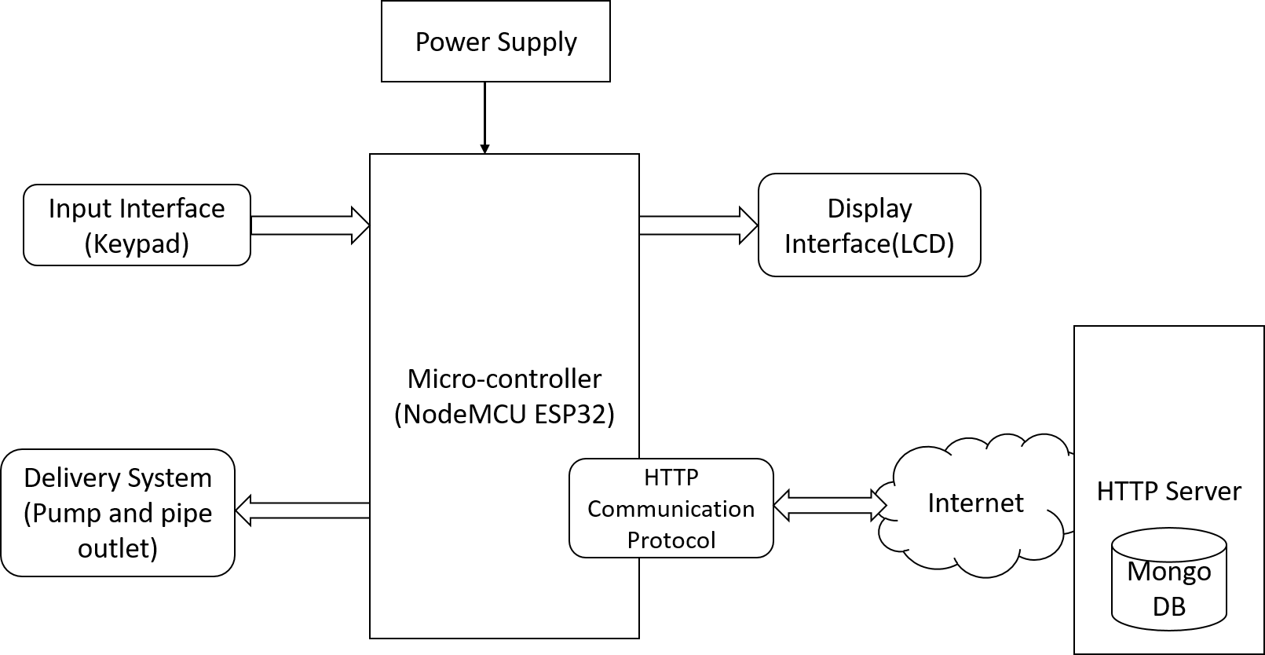

***Figure 3.1. Block diagram of the system***

The Block Diagram Representation of the Proposed System in Figure 3.1 depicts the various components and interfaces that make up the vending machine. The Input Interface allows the customers to select the quantity of coffee they desire and confirm their payment. The Display Interface provides feedback to customers to inform them of the product they have purchased and the state of their transaction. The Power Supply provides the necessary power to the microcontroller, and the Microcontroller is programmed to manage the control system and execute the functions of the vending machine. The Software consists of an HTTP server and a database that processes the M-PESA STK payment and stores the customer payment data. Finally, these components are all connected by the control system, which is in charge of the functioning of the whole system.

## **3.2. SYSTEM IMPLEMENTATION**

### **3.2.1. INPUT INTERFACE**

The input interface is the interface through which the customer inputs data in order to perform a transaction. This interface typically consists of a keypad, LCD, a button and a switch. The input interface is designed in such a way that makes it easy for the customer to use and understand.

The functioning of the input interface is to detect customer input and convert it into an appropriate signal that can be used by the control module. The input interface mainly allows users to enter their order for the desired quantity of coffee, initiate M-PESA STK payment, and confirm their order before the control system activates the dispensing mechanism.

### **3.2.2. DISPLAY INTERFACE**

The display interface is used for displaying feedback to the customer regarding their transaction. This typically includes data such as the quantity of the product selected, the amount to be paid, and other states of the transaction. The display interface was designed in such a way that it is clear and easy for the customer to understand.

### **3.2.3. POWER SUPPLY**

The power supply unit provides an electrical current to the other components. It is an essential part of the system and its effectiveness has an affect the performance of other components considerably. A switched-mode power supply (SMPS) was used in this project. This is because switched-mode power supplies are compact, power-efficient, typically better than 85%, and lightweight. Switched-mode power supplies are also extremely flexible from a design perspective.

### **3.2.4. MICROCONTROLLER**

The microcontroller is responsible for controlling the operation of the vending system. This typically includes managing the control system as well as executing the functions of the machine. NodeMCU ESP-32 microcontroller was used in this project because it’s more powerful, has more memory and is capable of handling more complex tasks and managing multiple operations simultaneously. It also allows communication over WI-FI.

### **3.2.5. SOFTWARE**

The software aspect of the project comprises three components, a control software based on Arduino programming, a powerful HTTP Server for processing M-PESA STK payment requests and a Database. The HTTP Server handles requests from customers and sending responses back to them. The server was developed using Nodejs.

The database is responsible for storing customer transaction information. The database used in this project was MongoDB mainly due to its ease of use.

### **3.2.6. DELIVERY SYSTEM**

The delivery system is used for delivering the coffee to the customer. The delivery mechanism used should be able to efficiently dispense the desired quantity of coffee. The components used include a submersible pump and a pipe outlet. The dispensing mechanism is activated by the control software when order details are correct and the M-PESA payment is confirmed to be successful.

## **3.3. FLOWCHART OF THE SYSTEM OPERATION**

Figure 3.2 shows the initial flowchart of the proposed system. The flowchart shows the steps taken right from the beginning until the end of a vending process. When a customer initiates a transaction, the automated coffee vending machine will prompt them to enter the order details. This will include the quantity of coffee they require. Then, the customer will be asked to enter their payment details, which includes the phone number to which the M-PESA STK push would be send. Once the customer has entered the required details, the system will send an M-PESA STK push to the customer's phone. The customer will then be prompted to review and accept the transaction.

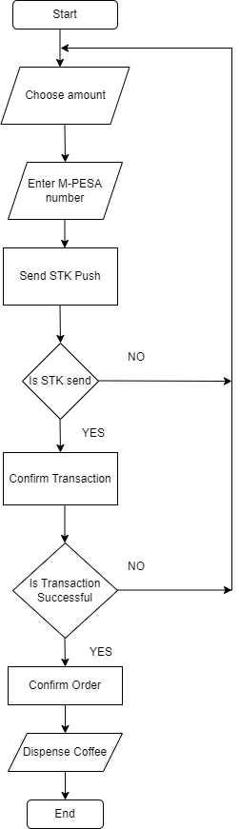

***Figure 3.2. Flowchart of the system***

If the system has successfully sent the M-PESA STK Push, the process will continue. The payment system will securely generate authentication tokens to verify the transaction and collect data on amount paid, transaction ID, and the success code of the transaction. The system then verifies if the transaction was successful, and engages the control system to dispense the desired amount of coffee once the transaction is established to have been a success. As soon as the coffee has been dispensed, the machine will reset itself back to its original state and be ready for the next customer.

However, if the system is unable to send the M-PESA STK Push, the process is aborted and the system will reset back to start. The same will occur if the customer is unable to complete the payment on their end. In such cases, the system will return to its original state in order to prepare for the next customer.

# **CHAPTER FOUR**

## **4.0. RESULTS AND DISCUSSION**

This chapter provides an overview of the achieved results. Some of the key features implemented successfully include a control module, a user interface, mobile payment system and a physical prototype of the coffee vending machine. The results are as discussed below:

## **4.1. SYSTEM PROTOTYPE**

A wooden prototype was implemented to accurately simulate the functions of the coffee vending machine and provide customers with an authentic vending experience. The prototype was designed to be structurally sound and capable of giving a realistic rendering of the system's performance.

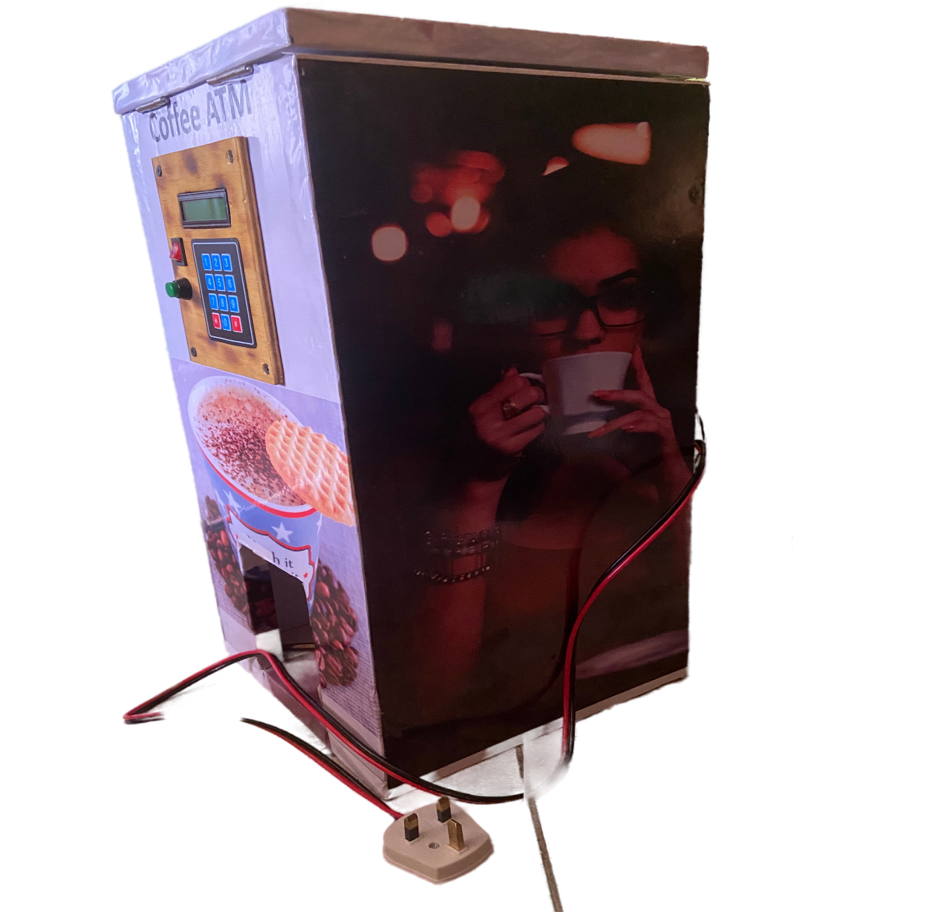

***Figure 4.1. System prototype***

The user interface and the control module were integrated into the prototype in such a way that users could easily enter their orders. Other key components and features of the prototype include a power supply, an insulated coffee storage container and a dispensing outlet.

## **4. 2. USER INTERFACE**

A user interface was implemented to allow users to make orders and initiate automated M-PESA payments. The user interface include a LCD display from where users can track the state of their transactions and monitor their inputs. It also includes a keypad that allows users to enter their order amount, and the phone number they would wish to use for making M-PESA payments.

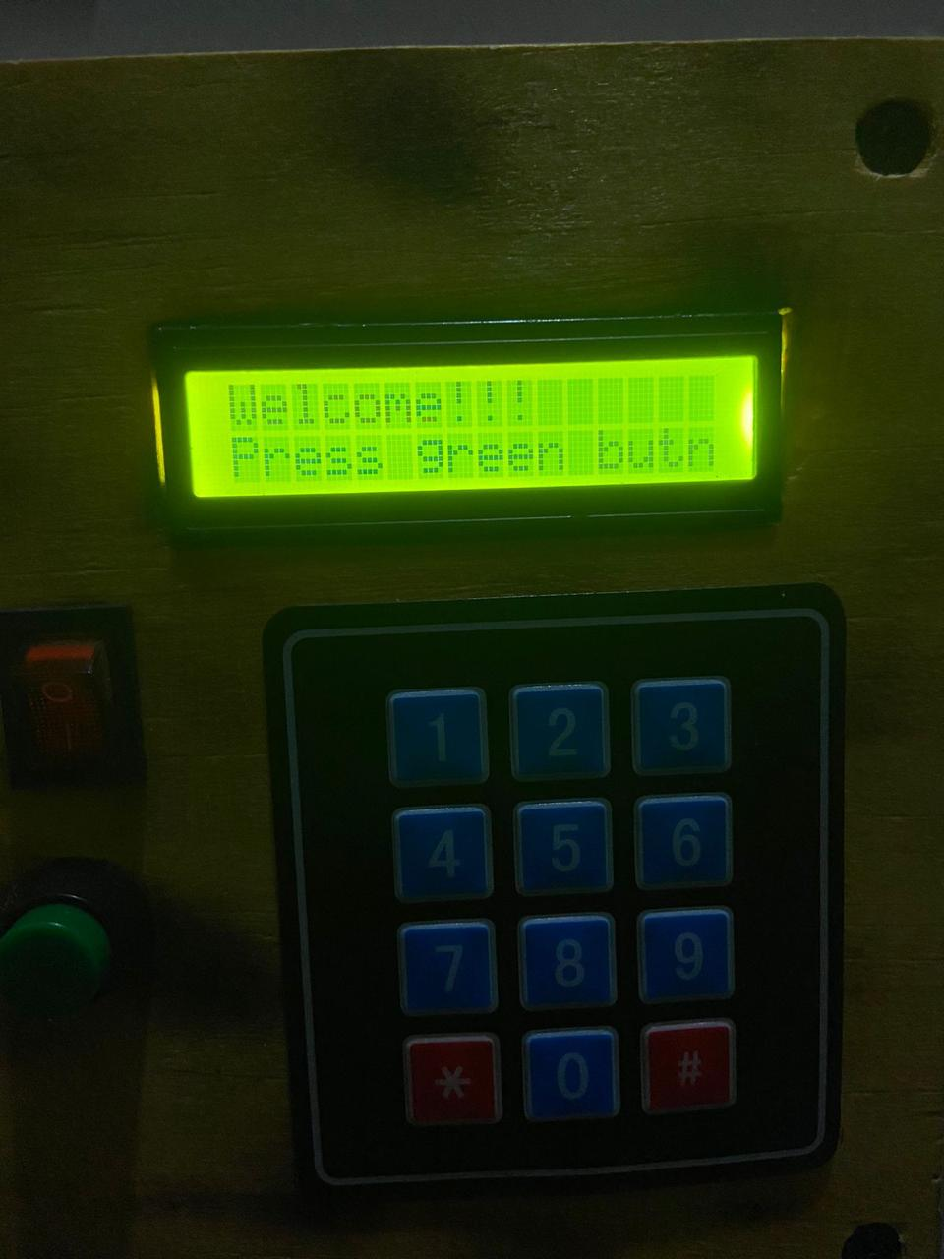

***Figure 4.2. User interface***

## **4.3. CONTROL MODULE**

A control module was successfully implemented to bridge the communication between the payment system and the coffee machine. The main components used in the control module include a Node-MCU ESP32 microcontroller, coffee pump, a switch, and a control button. The control module receives instructions entered by the user and accurately implements them. Some of the significant operations performed by the control module include displaying user inputs, allowing users to edit their inputs, providing an override system that allows manual transactions when necessary, and dispensing the desired amount of coffee correctly.

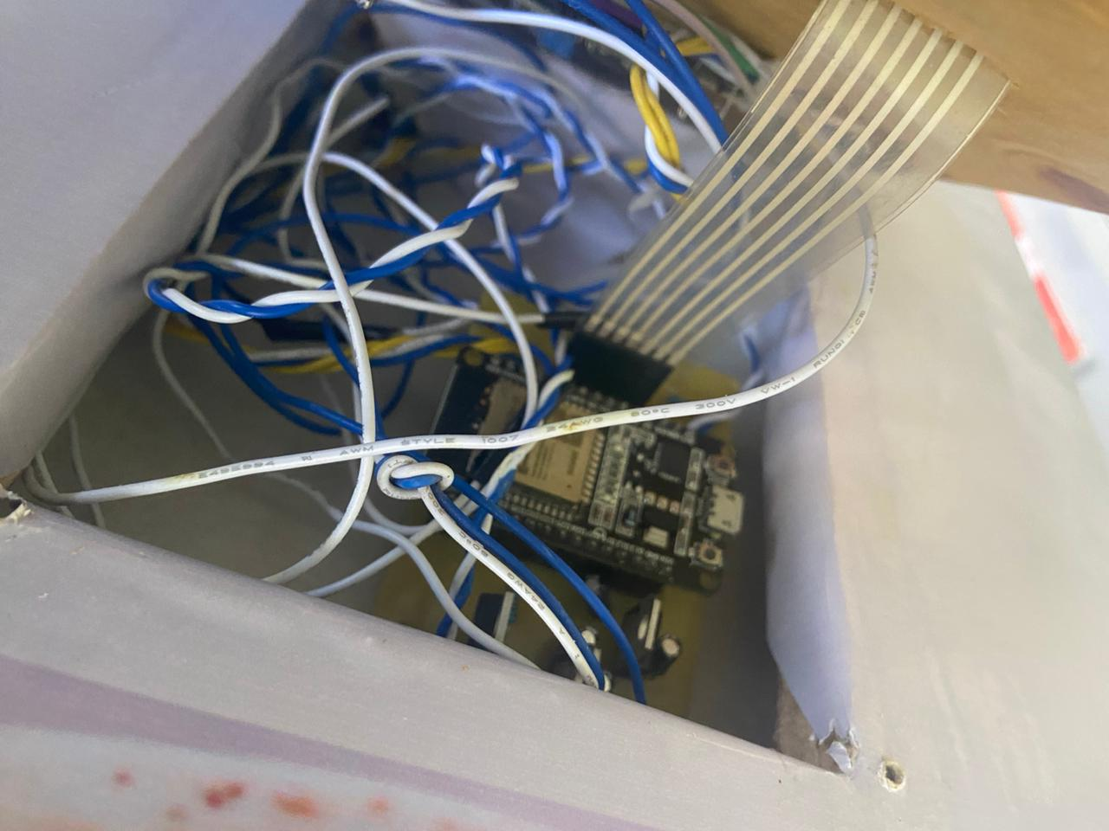

***Figure 4.3. Control module***

## **4.4. PAYMENT SYSTEM**

A payment software based on M-PESA STK method was also integrated to the coffee vending machine to help in making cashless payments. The payment system proved to be a secure and convenient method for customers to make payments. Based on the M-PESA STK method, it generates authentication tokens, sends STK push requests to users and confirms the whether the customer completes the transaction successfully. The system also collects essential data on customer payment details, which can be used for future analysis. Overall, the payment system was successful in providing a reliable and secure payment process for customers.

## **4.5. TESTING**

**Normal Operation (Automated)**



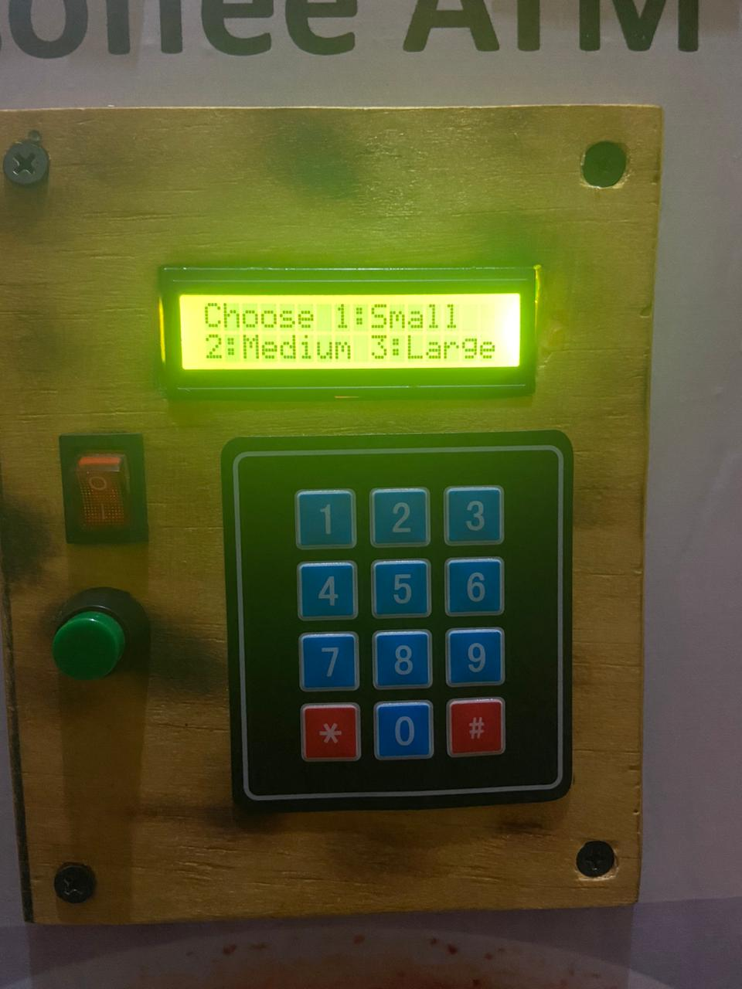

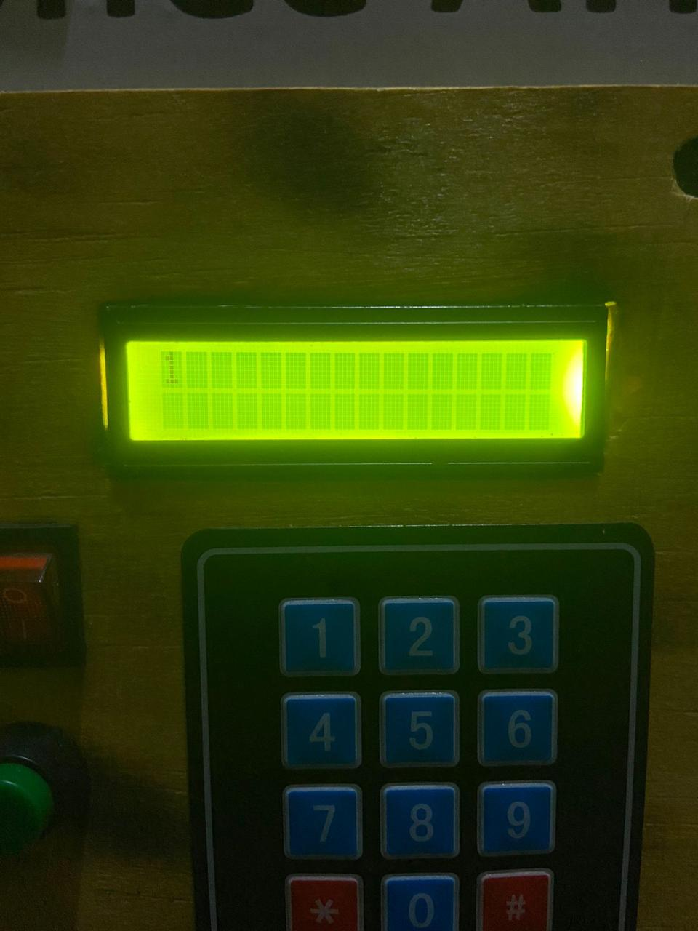

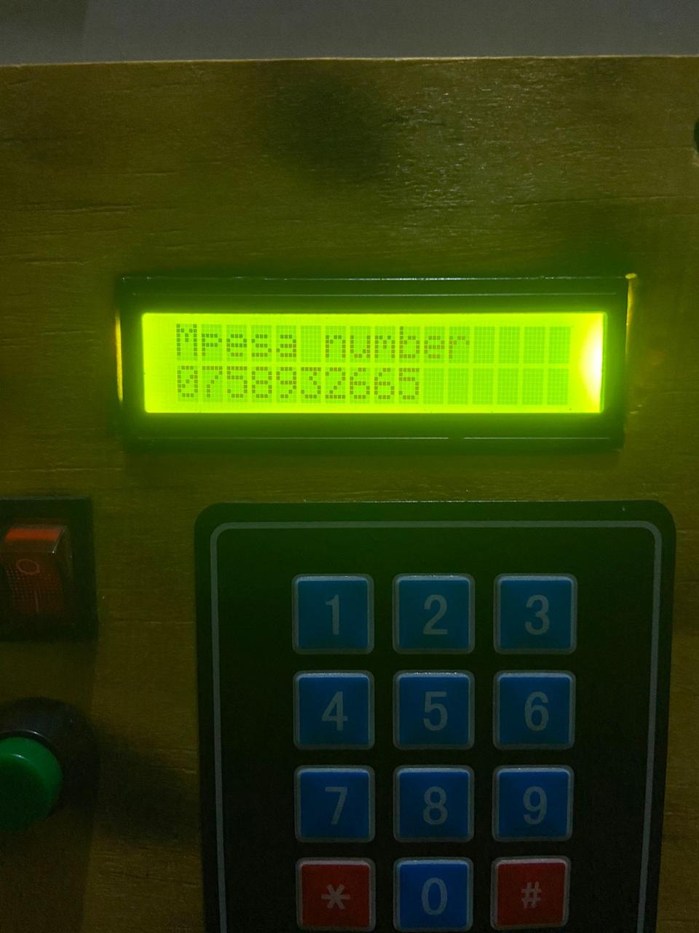

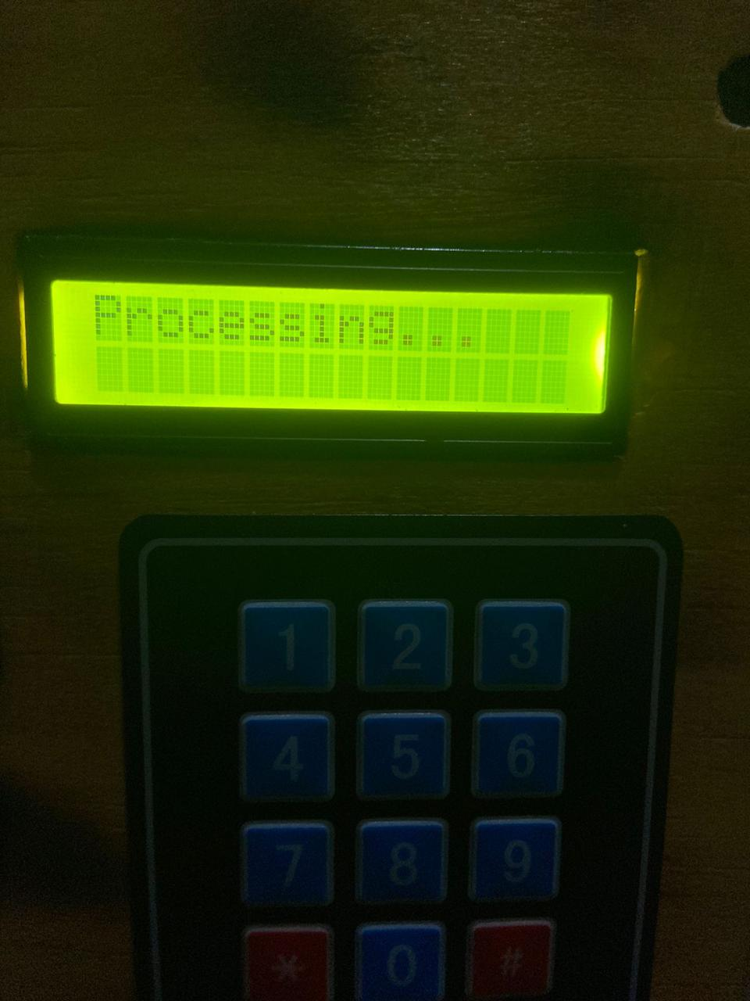

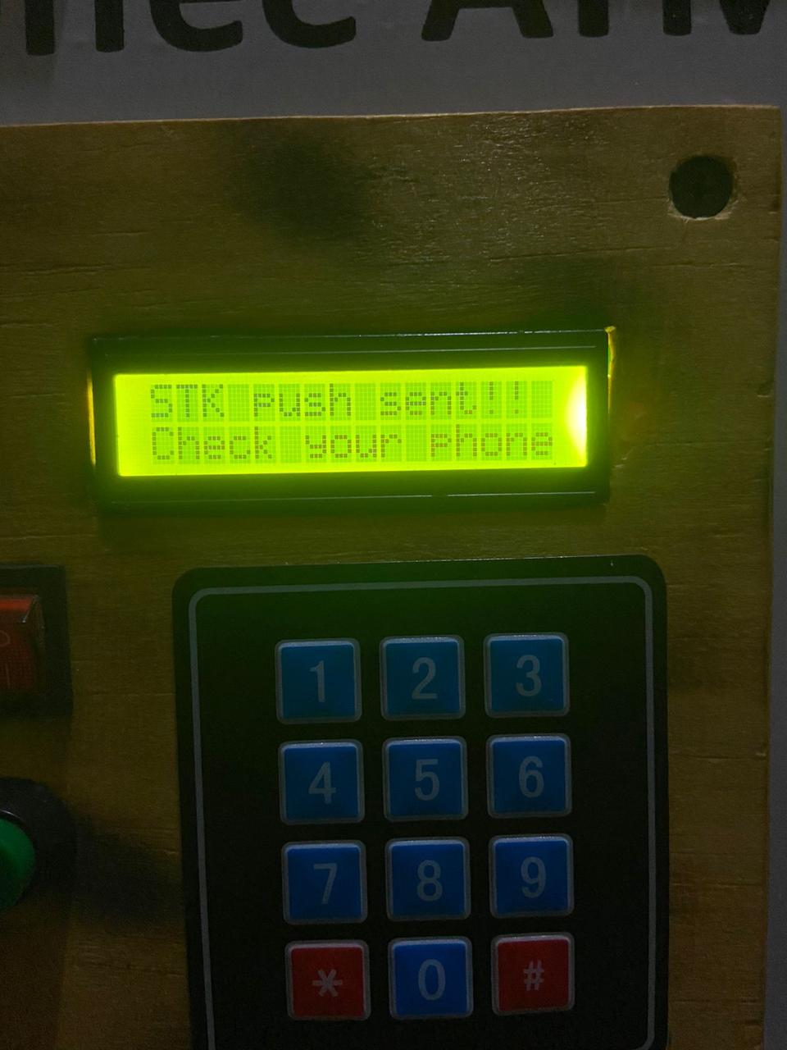

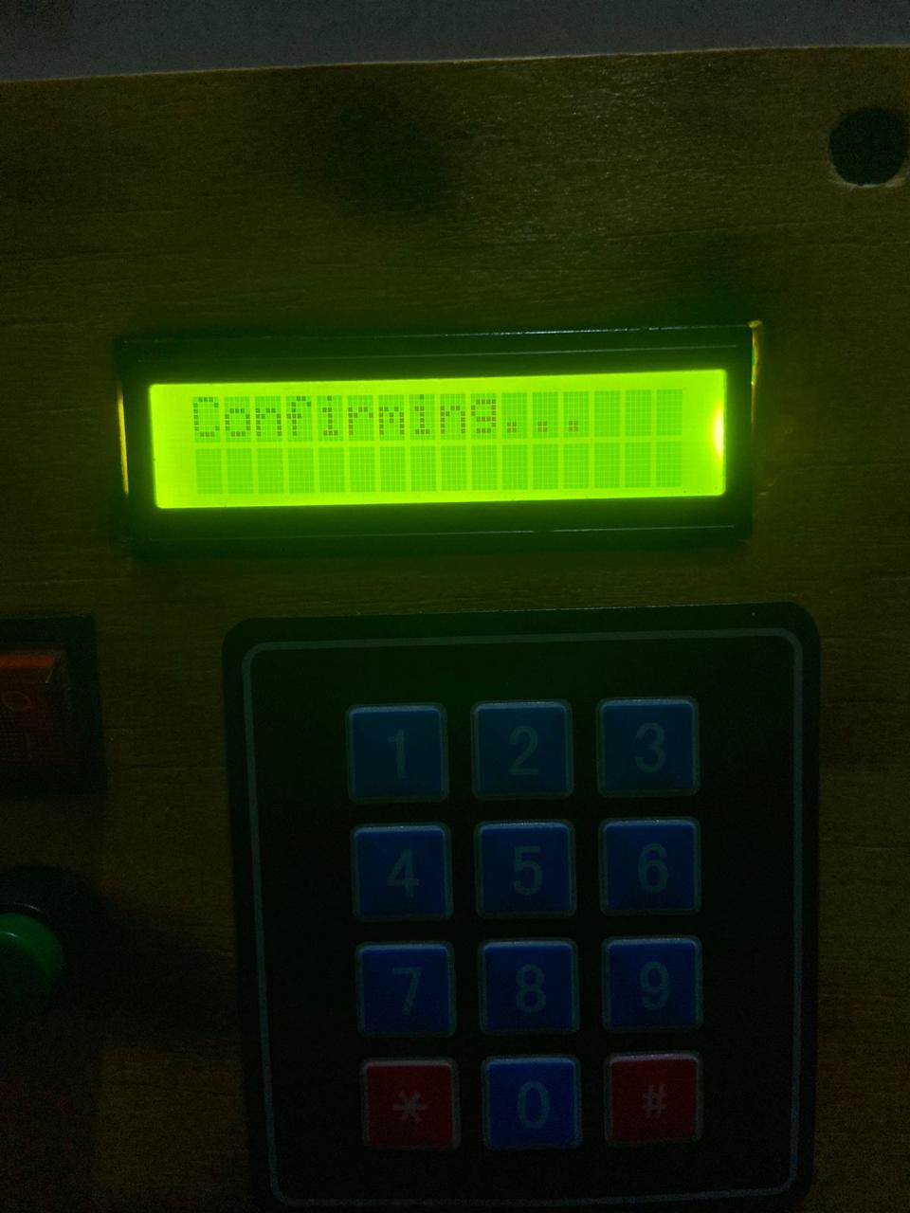

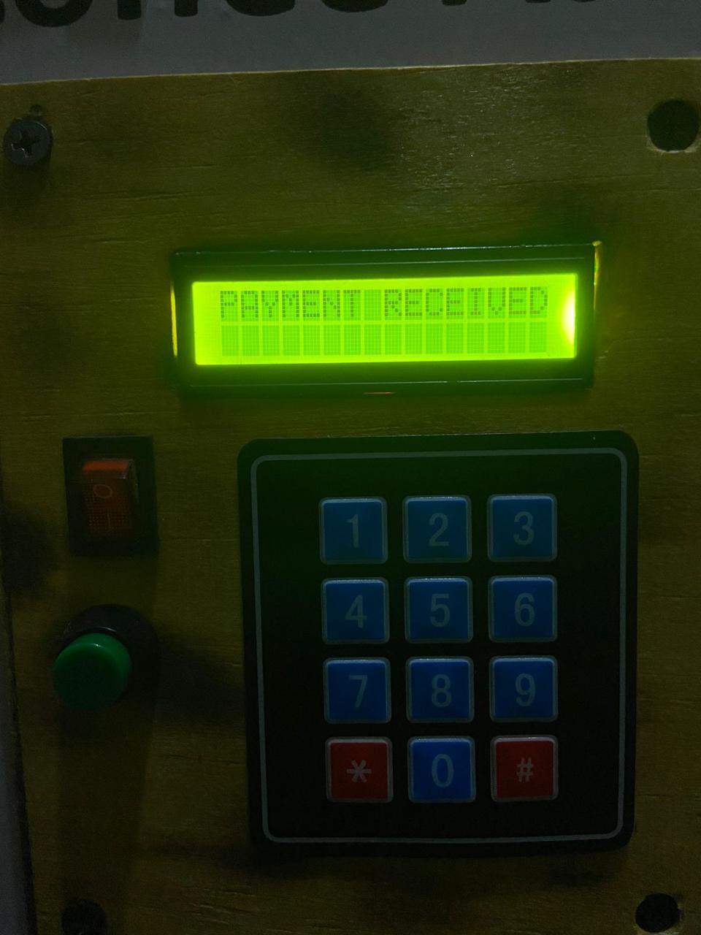

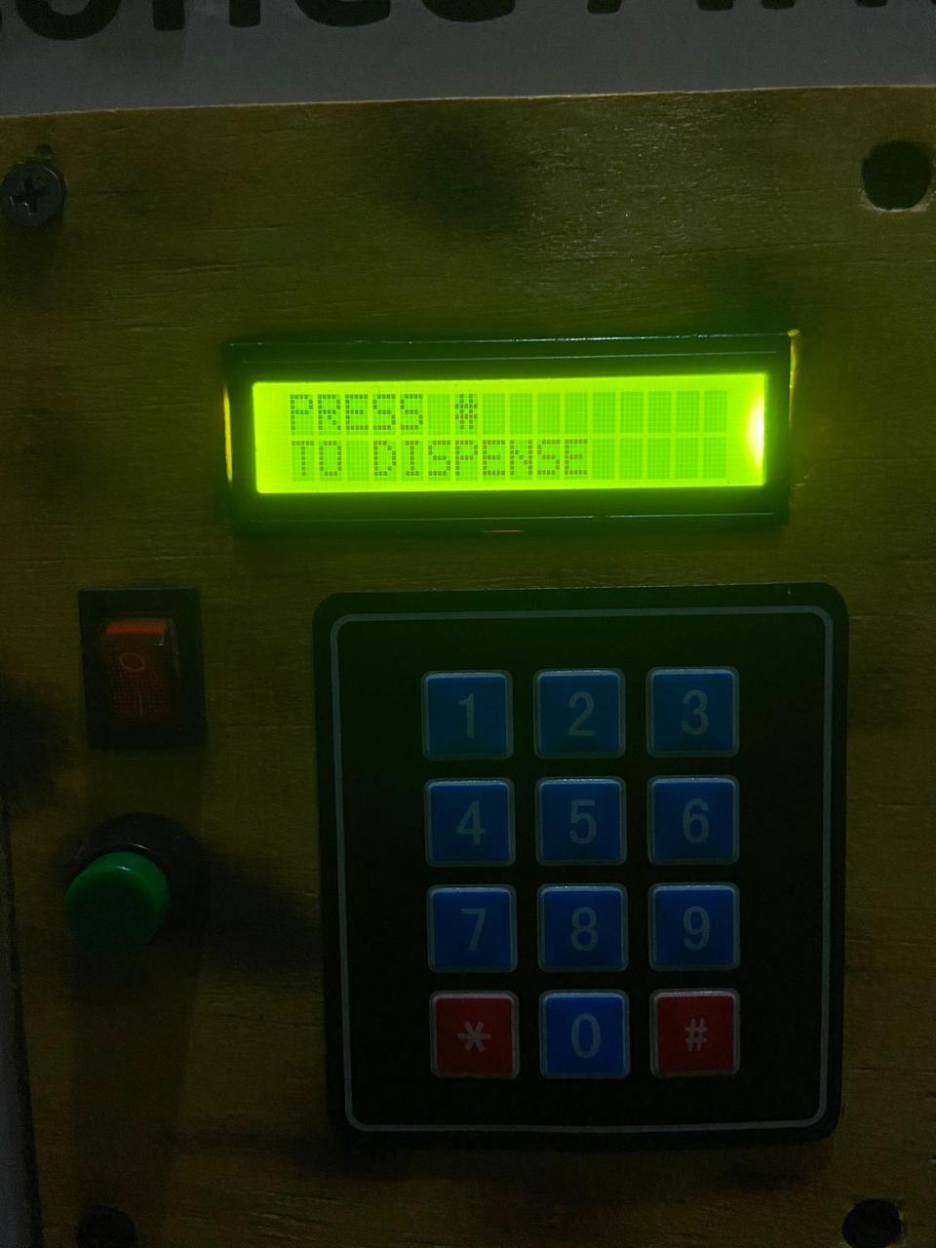

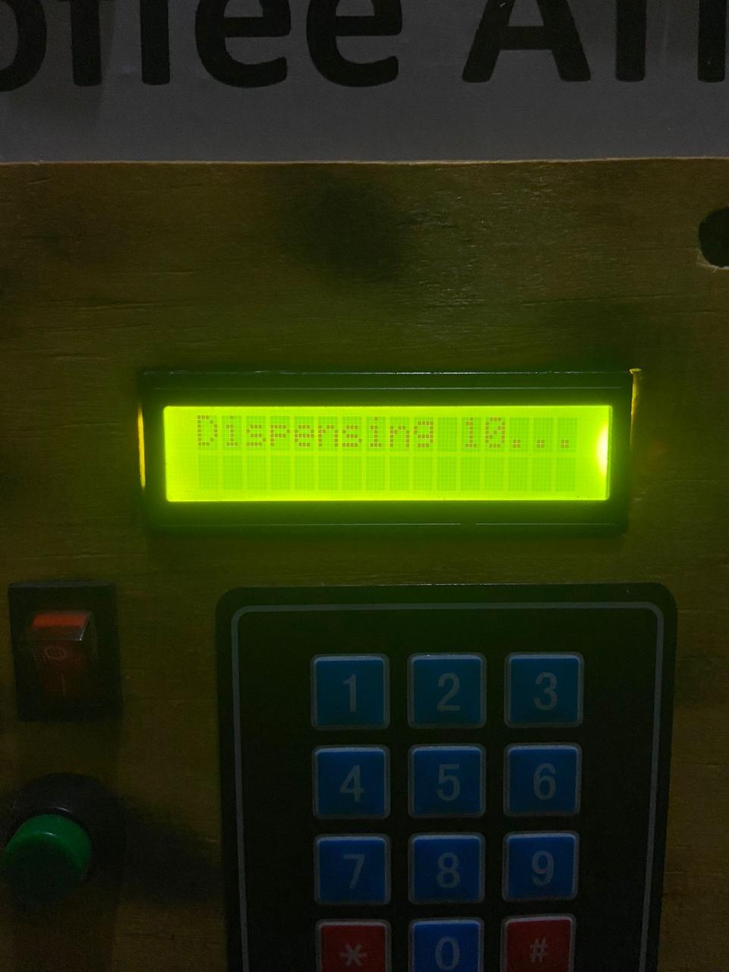

***Figure 4.5. Normal operation of the automated coffee machine***

The figure above shows the normal operation of the automated coffee machine. This operation is fully automated and uses the M-PESA payment system to process and authenticate transactions. The choice of quantity in this test was small and the same process is the same for all other quantities of coffee.

### **4.5.1. MPESA STK REQUESTS**

After choosing the desired quantity of coffee and entering the M-PESA phone number through the user interface, the system successfully sends a payment request to the client’s phone for the same amount entered. In the case provided below, the client chose size small as their desired quantity (ksh 10) and the M-PESA STK request had the same amount. The payment request cannot be manipulated by the client after it has been send by the system thus ensuring the reliability and security of the system’s payment process.



***Figure 4.5.1. M-pesa push notification***

Since it’s possible for a client to receive a payment request and fail to pay, the system further confirms the status of the transaction before any dispensing process can be initiated. When a payment request is sent, the system records the transaction on the database. A sample of a transaction recorded in the database is shown below.

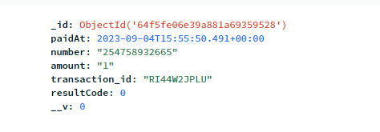

***Figure 4.5.2. A sample of successful transaction recorded in database***

The resultCode indicates the status of the transaction. When the resultCode is 0, it indicates that the transaction was completed successfully. Any other value of resultCode indicates that the transaction was no successful, and the user did not pay for the product. The payment system uses this result code to confirm the success of the transaction. If the system confirms that the client paid successfully, it proceeds to dispense the desired amount of coffee to the client.

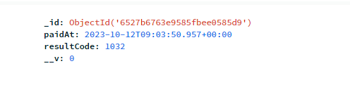

***Figure 4.5.3. A sample of unsuccessful transaction recorded in database***

Other transaction details such as amount, phone number and transaction ID are recorded for future use and authentication purposes.

### **4.5.2. QUANTITY DISPENSED**

The coffee machine dispenses coffee in three quantities; small, medium and large. The prices for these quantities are Ksh 10, 20, and 30 respectively. To test the accuracy of the dispensed amounts, coffee orders for all three sizes were made and the results are as shown below.

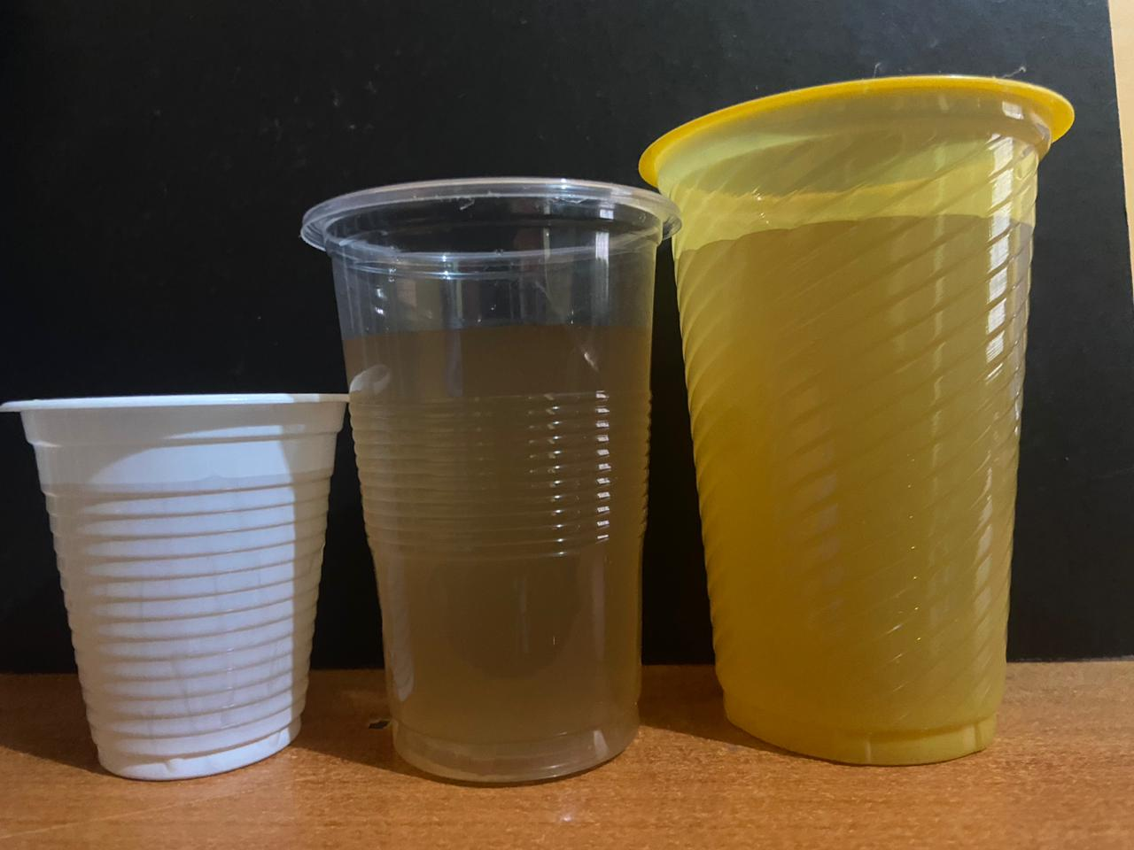

***Figure 4.5.4. Comparison of small, medium and large quantities of dispensed coffee***

The coffee machine accurately dispensed the desired amounts. Furthermore, orders of the same quantity (two large sizes) were made to confirm the accuracy of the machine in dispensing the same ordered amounts at different instances. The results are as shown below.

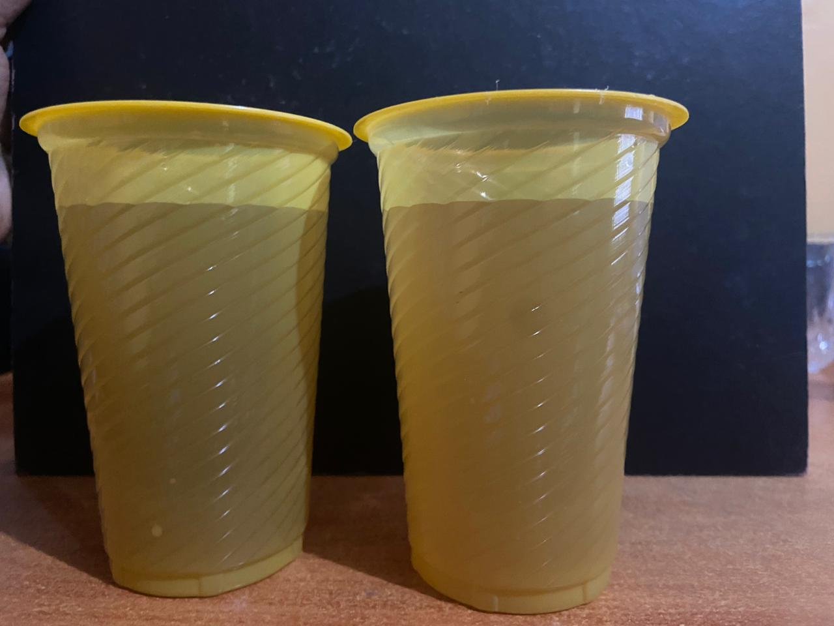

***Figure 4.5.5. Comparison of two large quantities of dispensed coffee***

When the two orders of large sizes were made, the dispensed coffee in both cases was the same hence proving the accuracy of the coffee machine in dispensing the desired amounts of coffee.

### **4.5.3. DATABASE ENTRIES**

The database records every M-PESA transaction made by the clients. The transaction details recorded include the phone number, amount paid, transaction ID and the resultCode(status) of the transaction. A transaction was made and the M-PESA payment message received by the client was compared with the entry in the database. Both records are as shown below:

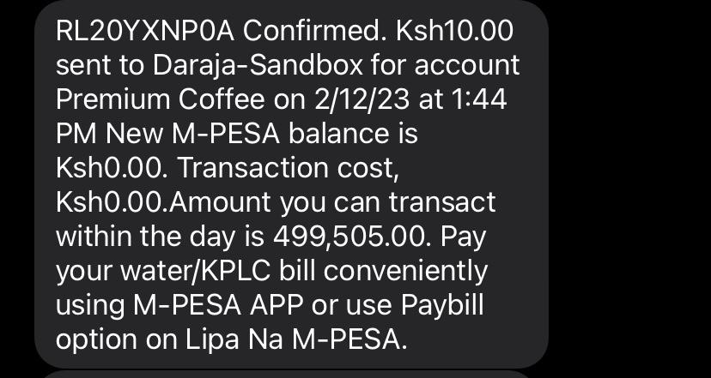

***Figure 4.5.6. M-pesa payment confirmation message received by client***

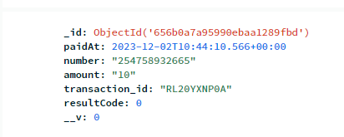

***Figure 4.5.7. Database record of the M-pesa transaction.***

The records showed that the transaction ID and amount paid in both cases were similar hence validating the ability of the system to accurately record the transactions made.

### **4.5.4. OVERRIDE SYSTEM**

The override system allows the coffee machine attendants to make manual transactions on behalf of clients in the rare cases when clients wish to pay with cash or in case of M-PESA failures in processing the payments. When the override system is initiated, it prompts the attendant to enter the password so as to authorize the vending process.

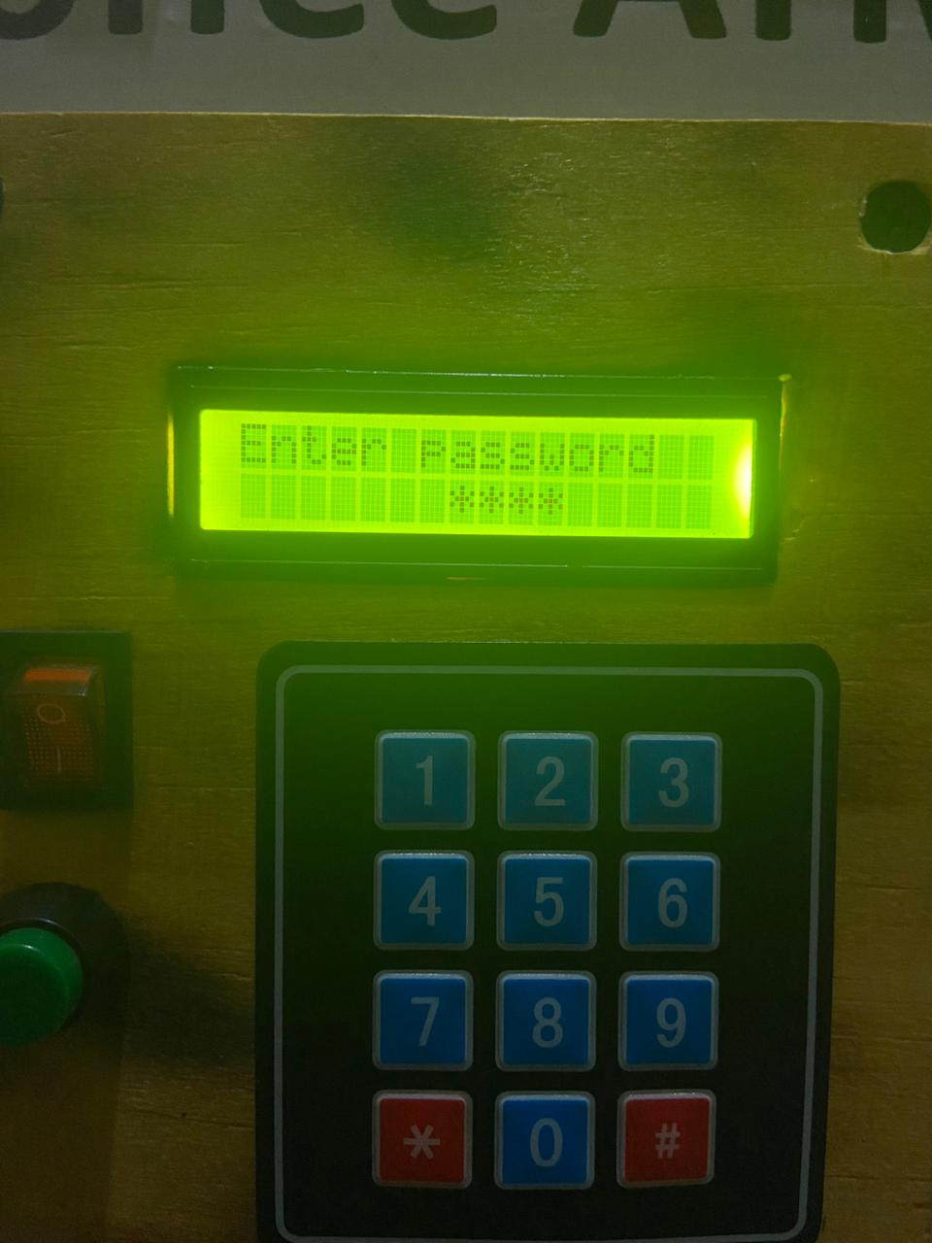

***Figure 4.5.8. Password-protected override system***

If the entered password is correct, the attendant can proceed to enter the amount to be dispensed. When the entered password is incorrect, the system reverts back to start.

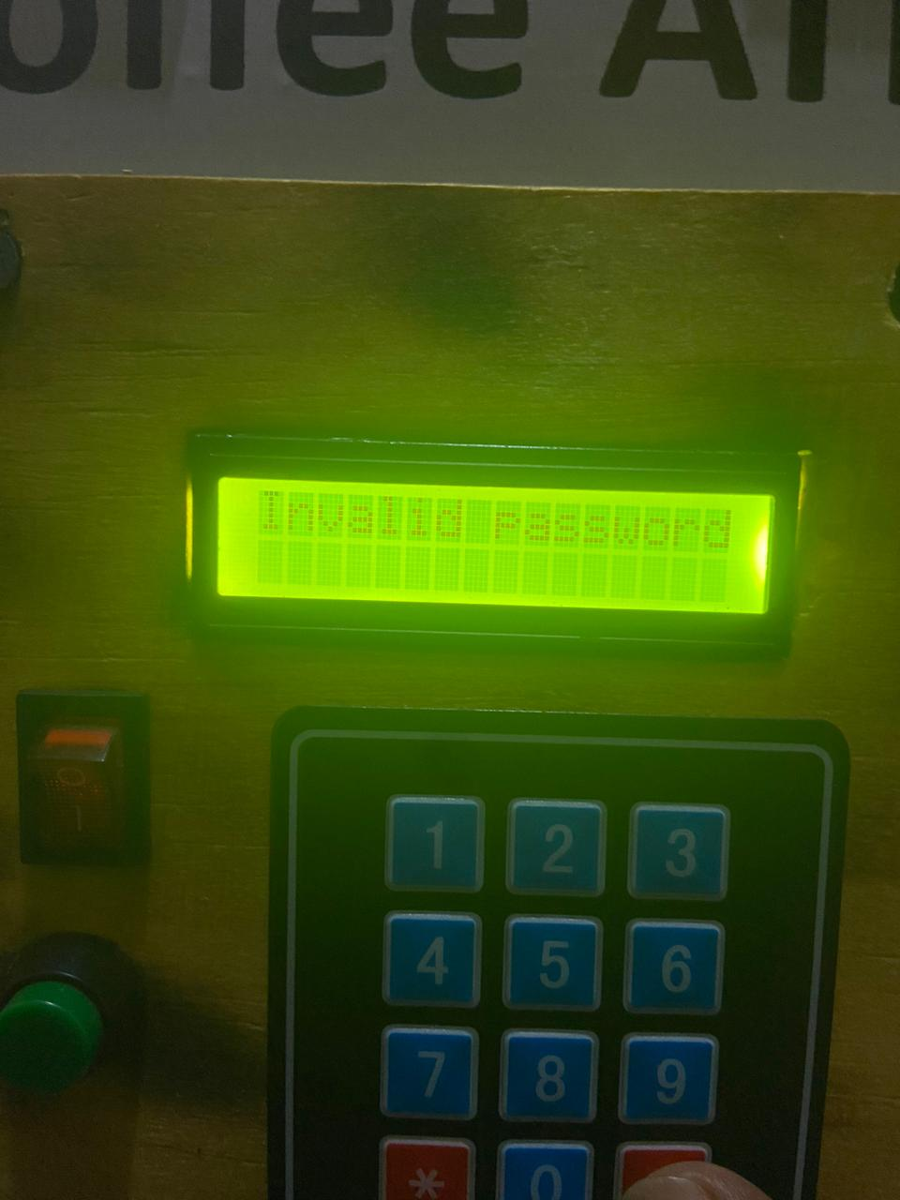

***Figure 4.5.9. Error message on the override system***

## **4.6. DISCUSSION**

A novel coffee vending machine was developed. The vending machine was integrated with a control module and a mobile payment system that fully automated its operations. The automation of the coffee vending process contributes to reduced cost of operations and other delays that are associated with coffee outlets that require human labour to operate. The payment system was achieved by using M-PESA STK method which automatically sends payment requests to customers after making an order. The mobile payment system ensures the safety and reliability of vending transactions and overcomes the challenges associated with cash payments systems such as risk of fraud. Additionally, mobile money transactions have continually been increasing since 2018.

***Figure 4.6. Percentage of micro and small enterprises (MSEs) using mobile money for business transactions in Kenya from 2018 to 2021***

According to data collected by Statista, over 60 percent of micro and small enterprises (MSEs) in Kenya used mobile money for business transactions as of March 2021 [27]. The share slightly increased from 59 percent in February 2020. A huge shift in the use of mobile money by small businesses was measured, however, between 2018 and 2020, even before the coronavirus (COVID-19) pandemic. In November 2018, only 18 percent of micro and small enterprises used mobile payments in Kenya.

The data collected from the vending transactions is also stored in a database and can be used to perform sales analysis and analyse user buying trends. With the growing customer preference for mobile money transactions and the efficiency of automated systems, the automated coffee vending machine would easily be adopted in the Kenyan market.

The automated coffee vending machine was also designed to overcome some of the challenges associated with fully automated systems. For instance, customers who do not have mobile money could be allowed to make their purchase using cash under the help of an attendant. This can be achieved through the override system integrated to the coffee vending machine. The override system is password protected to ensure the security of manual transactions and it also allows owners to change their password in case a breach is detected. Other interfaces of the vending machine include the user interface and the dispensing outlet which are user-friendly and do not involve complex steps or operation. The coffee storage container was thermally insulated using mineral foam to ensure that the coffee maintained its temperature for a longer period.

# **CHAPTER FIVE**

## **5.0. CONCLUSION AND RECOMMENDATION**

This chapter provides a summary of the findings in this project and their implications. It also provides recommendations that would be beneficial in future development of a similar project.

## **5.1. CONCLUSION**

Availability of vending machines is important as many people depend on them to conveniently access products. These machines are used in dispensing a variety of products such as candy, drinks, food and other consumables that do not require the presence of a salesperson. In this project, an automated coffee vending machine was implemented to accurately dispense desired amounts of coffee to customers. The vending process is fully automated and customers can make cashless payments through M-PESA. The automated coffee vending machine can be run by different organizations or individuals to boost their sources of income. Some of the benefits associated with the coffee vending machine include reduced cost of operations, increased efficiency and better security of vending transactions. Consumers do not like standing in queues due to the number of errands they run. Innovative business can therefore turn to automated coffee vending machines to meet consumer demand and preferences. The machines can be strategically located in various centres for competitive advantages. Investors who chose to adopt the automated coffee vending machine can also enjoy other benefits such as reduced risk of fraud and access to consumer purchases data which can be used to make financial analyses and predict consumer buying trends.

Although automated coffee vending machines can revolutionize the beverages market, it can also face challenges such as system failure or instances of customers wanting to make cash payments for the product. This project has taken into consideration such challenges and they can easily be solved by the override system which allows an attendant to make manual transactions on behalf of a client. The override system is password-protected hence safe from manipulations. The control module is also integrated into the prototype in such a way that it can be easily accessed in case of system failure and new software can be re-installed to solve such issues. In conclusion, the project successfully achieved its expected results in terms of the control module, payment system, and system prototype. The system proved to be efficient, secure, and user-friendly, providing customers with a seamless coffee vending experience. With future improvements and enhancements, this system has the potential to revolutionize the coffee vending industry.

## **5.2. RECOMMENDATIONS**

The coffee vending machine provides consumers with a fully automated vending process whereby users can enter and edit their orders and make payments through M-PESA. The mobile payment system is accessed by the control module by sending HTTP requests to the system over WI-FI. Although this method works seamlessly, future developers can consider the use of a GSM module to send and receive HTTP request from the payment system. This approach can overcome the challenges that can face the current method such as slow WI-FI and long distance communication. Other future considerations include increasing the varieties that the coffee machine can dispense and the inclusion of an additional payment method to ensure consumers have a wide range of options.

**PROJECT TIME PLAN**

Table 1: Project time plan

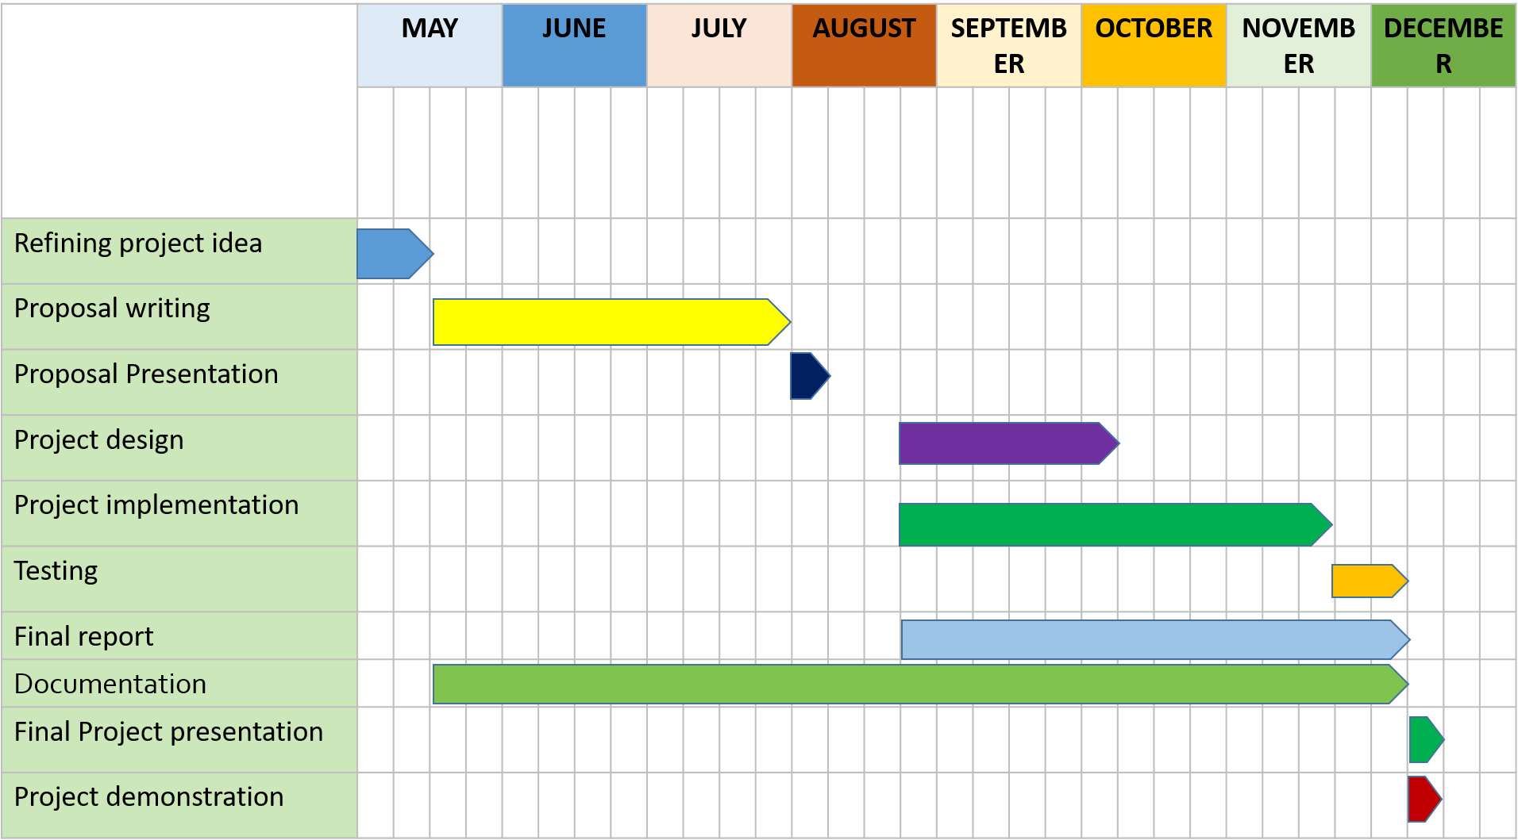

**BUDGET**

Table 2: Project budget

|  |  |  |
| --- | --- | --- |
| **Component** | **Quantity** | **Amount (Ksh)** |
| Microcontroller | 1 | 1,400 |
| Resistors | 10 | 100 |
| Copper clad | 1 | 200 |
| Capacitors | 3 | 120 |
| Pump | 1 | 250 |
| Sensors | 2 | 500 |
| Transistors | 3 | 150 |
| Keypad | 1 | 200 |
| Connecting wires | 20 | 40 |
| Cardboard | 5 | 5,000 |
| LEDs | 4 | 20 |
| Button | 2 | 20 |
| Display(LCD) | 1 | 500 |
| **Total** | | 8,500 |

# **REFERENCES**

[1] S. Gruber, R. Buber, B. Ruso, and J. Gadner, “The commodity vending machine,” *InForum Ware Int*, vol. 2, pp. 32–42, 2005.

[2] Q. Iqbal, L. E. Whitman, and D. Malzahn, “Reducing customer wait time at a fast food restaurant on campus,” *J. Foodserv. Bus. Res.*, vol. 15, no. 4, pp. 319–334, 2012.

[3] D. T. Wiyanti and M. N. Alim, “Automated vending machine with IoT infrastructure for smart factory application,” in *Journal of Physics: Conference Series*, IOP Publishing, 2020, p. 032038.

[4] R. Preetilatha, R. Ramkumar, S. M. Ramesh, S. Kiruthika, and M. Bharani, “Stationary Vending Machine,” *Int. J. Innov. Sci. Eng. Technol. IJISET*, vol. 1, no. 9, pp. 8–12, 2014.

[5] N. Ratnasri and T. Sharmilan, “Vending Machine Technologies: A Review Article,” *Int. J. Sci. Basic Appl. Res. IJSBAR*, vol. 58, no. 2, pp. 160–166, 2021.

[6] V. Sibanda, L. Munetsi, K. Mpofu, E. Murena, and J. Trimble, “Design of a high-tech vending machine,” *Procedia CIRP*, vol. 91, pp. 678–683, 2020.

[7] E. Murena, V. Sibanda, S. Sibanda, and K. Mpofu, “Design of a control system for a vending machine,” *Procedia CIRP*, vol. 91, pp. 758–763, 2020.

[8] A. Dijkstra, “How vending machines are making life better for Kenyans,” *BBC News*, Dec. 14, 2021. Accessed: Jul. 23, 2023. [Online]. Available: https://www.bbc.com/news/business-59517551

[9] A. Mohan, N. Tiwari, R. Ghosh, and A. A. Shinde, “Coin Operated Water Dispenser,” 2017.

[10] A. Ramzan, S. Rehman, and A. Perwaiz, “RFID technology: Beyond cash-based methods in vending machine,” in *2017 2nd International Conference on Control and Robotics Engineering (ICCRE)*, IEEE, 2017, pp. 189–193.

[11] V. Kanagasabapathi, K. Naveenraj, V. Neelavarnan, and S. N. Raj, “Automatic chocolate vending machine,” in *2019 5th International Conference on Advanced Computing & Communication Systems (ICACCS)*, IEEE, 2019, pp. 584–587.

[12] A. Brolin, R. Mithun, V. Gokulnath, and M. Harivishanth, “Design of automated medicine vending machine using mechatronics techniques,” in *IOP conference series: Materials science and engineering*, IOP Publishing, 2018, p. 012044.

[13] P. Kumar, S. Singh, M. Choudhary, and K. Singh, “Solar Powered Medic Vending Machine,” in *2020 2nd International Conference on Advances in Computing, Communication Control and Networking (ICACCCN)*, IEEE, 2020, pp. 465–468.

[14] S. Sambhi and P. Dahiya, “Reverse vending machine for managing plastic waste,” *Int. J. Syst. Assur. Eng. Manag.*, vol. 11, pp. 635–640, 2020.

[15] D. Mariya, J. Usman, E. N. Mathew, and P. H. H. Aa, “Reverse vending machine for plastic bottle recycling,” *Int J Comput Sci Technol*, vol. 8, no. 2, pp. 65–70, 2020.

[16] K. Siebenhandl, G. Schreder, M. Smuc, E. Mayr, and M. Nagl, “A user-centered design approach to self-service ticket vending machines,” *IEEE Trans. Prof. Commun.*, vol. 56, no. 2, pp. 138–159, 2013.

[17] H. Henderson, K. Grace, N. Gulbransen-Diaz, B. Klaassens, T. W. Leong, and M. Tomitsch, “From Parking Meters to Vending Machines: A Study of Usability Issues in Self-Service Technologies,” *Int. J. Human–Computer Interact.*, pp. 1–15, 2023.

[18] P. Desai, M. S. M. Jadhav, M. P. S. Patil, and M. N. S. Giri, “Automatic chocolate vending machine by using Arduino Uno,” *Int. J. Innov. Res. Comput. Sci. Technol. IJIRCST ISSN*, pp. 2347–5552, 2017.

[19] H. Y. Yang and X. M. Zhu, “Design of a vending machine control system,” *Appl. Mech. Mater.*, vol. 644, pp. 786–789, 2014.

[20] B. R. Manalo, M. L. V. Pereña, and K. L. J. Vicedo, “Coin operated printing machine.,” PhD Thesis, De La Salle University-Dasmarinas, 2014.

[21] L. Monostori, “Cyber-physical production systems: Roots, expectations and R&D challenges,” *Procedia Cirp*, vol. 17, pp. 9–13, 2014.

[22] A. Singh, “Touch screen based automated medical vending machine,” *Int. J. Innov. Res. Sci. Technol.*, vol. 1, no. 11, 2015.

[23] D. Thakwani and N. Tripathi, “PLC Based Change Dispensing Vending Machine using image processing technique for identifying and verifying currency,” *Int. Res. J. Eng. Technol.*, vol. 3, no. 11, 2016.

[24] C. Discriminator and M. AT89C51, “Real Time Embedded Based Drinking Water Vending Machine,” *Asian J. Sci. Technol. Vol*, vol. 5, no. 12, pp. 804–809, 2014.

[25] M. V. Karthika, S. Jagadeesh, R. A. Karthick, and K. S. Teja, “Smart Computerized Vending Machine Enhanced With IOT Technology,” 2019.

[26] S. Pandey and M. M. M. Gogate, “Iot based smart automatic juice vending machine,” *Int. J. Eng. Technol.*, vol. 5, no. 2, pp. 171–176, 2017.

[27] N. Crowling, “Kenya: mobile money usage by small business 2021,” Statista. Accessed: Nov. 25, 2023. [Online]. Available: https://www.statista.com/statistics/1249097/usage-of-mobile-money-by-micro-and-small-businesses-in-kenya/